Contracts for farmers’ price risk management. Evaluation under different decision theories and framings.
Riccardo Spada¹, Lukas Åkerman², Simone Cerroni^{3,4}, Miranda P.M. Meuwissen¹, Laura Moritz³, Jens Rommel², Tobias Dalhaus^{1,5}
¹ Business Economics Group, Wageningen University & Research, Wageningen, Netherlands
² Department of Economics, Swedish University of Agricultural Science (SLU), Uppsala, Sweden
³ Center Agriculture Food Environment (C3A), University of Trento, Trento, Italy
⁴ Department of Economics and Management, University of Trento, Trento, Italy
⁵ Agribusiness, Sustainable Food Systems Research Centre, Rhine-Waal University of Applied Sciences, Kleve, Germany
Abstract
XXX
JEL Codes: XXX
Keywords: XXX
Target Journals:
- XXX

Introduction
In recent decades, energy-intensive inputs in agriculture, such as mineral fertilizers, have experienced considerable volatility, putting farmers' overall income and, thereby, food security at risk. Inorganic fertilizers, whose production requires substantial amounts of energy, stand out as a critical component for modern agriculture (European Commission, 2022; FAO, 2024). In particular, nitrogen-based (N) fertilizers are the most important nutrient for crop production (IFA, 2022). However, price shocks caused by recent geopolitical crises are not completely transmitted to output prices (Dong et al., 2025). Higher prices can reduce farmers’ ability to apply optimal nutrient levels, thereby lowering yields and jeopardizing food security.
While in the long-run farms must reduce dependency on fossil energy intensive inputs, price risk management can mitigate the financial exposure to price volatility in the short run. A strategy to manage price risk is to use financial tools such as forward contracts, futures and options, and price insurance (Hardaker et al., 2015). But farmers’ adoption of such tools is lower than what would be expected from utility-maximizing behavior of a risk-averse decision-maker(Spada et al., 2025).
Many farmers’ decisions deviate from pure profit maximization and are better explained by considering risk preferences by using an expected utility framework, such as fertilizer decision (Moritz et al., 2026). Nonetheless, a growing body of empirical evidence shows that farmers’ choices often depart from the assumptions of Expected Utility Theory (EUT). For example, producers display loss aversion and probability weighting (Finger et al., 2024), consistent with Cumulative Prospect Theory (CPT) (Tversky & Kahneman, 1992). Additionally, adoption decisions might be narrowly framed as stand-alone investments (Barberis et al., 2006), instead of a risk management strategy within a broader farm portfolio (broad framing). Therefore, CPT has been effectively used to better explain adoption decisions of risk management tools (Mattos et al., 2008; Babcock, 2015). Further, agricultural commodity price risk management literature focuses mainly on output prices (Spada et al., 2025), underscoring the need for further research on the input side.
In this paper, we aim to adjust contract specifics of financial tools for farmers’ input price risk management to better fit farmers' behavioral preferences. Based on a simulation exercise, we show how contract adjustments, such as introducing a price ceiling, potentially affect farmers utility under EUT and CPT, as well as under broad and narrow framing. This leads to a conclusion about which contract specifics might be suitable under different farmers’ preferences and framing scenarios.
Our study extends the literature in two ways. First, there is a very limited conceptualization of farmers’ price risk management decisions beyond standard expected utility theory (Spada et al., 2025). We thus introduce a framework for input price risk management under risk using different framings and preference scenarios, thereby paving the way for experimental research to test for correlations between elicited preferences (e.g. using XXX) and financial price risk management tool adoption. Second, we contribute to the emerging literature on behavioral contracts for farmers’ risk management that better consider farmers’ actual decision making and preferences in contract design (e.g., Dalhaus et al., 2020).
To achieve our objective, we first provide a theoretical background and conceptualize how farmers might assess this decision under different decision theories (EUT and CPT) and framings (broad and narrow). We then build a simplified profit function of wheat production under risk. Subsequently, we define contract specifications of price risk management tools, that might affect farmers’ evaluation of these tools in terms of their utility under different behavioral models and framings. We then employ a bio-economic model by integrating a crop simulation with decision models under risk and ambiguity to test how adjusted contracts affect utility values (Finger, 2012). First, we parametrize the bio-economic model using simulated nitrogen and yield relationship from a crop model and an econometric procedure to estimate stochastic relations between nitrogen and yield. Second, we estimate nitrogen and yield price dynamics. Lastly, we incorporate the obtained information in the economic decision models and evaluate the effect on the outcome distribution for the different models and framing.
We find that under standard EUT preferences the behaviorally adjusted contract is attractive to farmers when broadly framed as a risk management tool, but when the decision is narrowly framed as an investment, we find that it doesn’t provide any benefit. Under CPT preferences, the adjusted contract is not attractive to farmers, both when broadly and narrowly framed. We conclude that, while promising, to make these types of contracts attractive to farmers, a more holistic approach that considers also output prices might provide better results. The remainder of the paper is organized as follows. In section 2, we lay down the theoretical background. First, we review the most common theories of farmers decision-making under risk and ambiguity. Second, we develop a bio-economic production model for fertilizer price risk decision-making. Building on this, we introduce different decision framing and propose behavioral adjustments to risk management tools. In section 3, we describe our methodology and in section 4, we present the data and the assumptions used. We present the results of the optimization model in section 5, and discuss them in section 6. We conclude in section 7.

Theoretical background

Theoretical frameworks on risk and ambiguity
Farmer decision-making behavior can be modeled using a variety of theoretical frameworks that capture different attitudes toward risk and ambiguity. We define risk as situations where the probabilities of different outcomes are known, while ambiguity refers to situations where these probabilities are not known (Knight, 1921). Traditional approaches that model decisions under risk and ambiguity often rely on Expected Utility Theory (EUT). However, empirical evidence suggests that decision-makers may deviate from purely EUT maximizing behavior. To capture these deviations, alternative models, most prominently Cumulative Prospect Theory (CPT) by Tversky & Kahneman (1992), have been proven useful to better describe farmer behavior (Bocquého et al., 2014; Babcock, 2015). CPT accounts for loss aversion, probability weighting, and reference dependence. Unlike risk, where probabilities of different outcomes can be estimated from historical data, ambiguity occurs when the probabilities are not available or decision-makers do not know them. In this context, the α-Expected Utility (αEU) model (Ghirardato et al., 2004), by accounting for ambiguity aversion, might be a better fit to explain farmers' behavior in ambiguous situations.
Under standard EUT assumptions, a common approach is to model farmers' behaviour as maximiser of certainty equivalent (CE). The CE of a risky outcome $(x)$ denotes the guaranteed payoff level that has the same utility as the expected utility of the risky outcome. Risk averse farmers are willing to reduce risk exposure by paying a risk premium. The expected outcome $E\left(x\right)$ is thus reduced by the risk premium as follows:
$$\begin{aligned}CE=E(U)≈{ E\left(x\right)- \frac{δ}{2}Var\left(x\right)}\#\left(1\right)\end{aligned}$$
where $δ$ is absolute risk aversion. While still relevant for normative assessments, farmers decisions about financial tools are in general not consistent with EUT (XXX).
Behavioral economics extensions of EUT might better explain actual farmers behavior. Thus, assuming CPT preferences, where gains and losses are considered as deviations from a reference point, decision-makers might maximize the prospect value $\left(V\right)$ of a risky outcome as:
$$\begin{aligned}\max{V= }\sum_{i=1}^{n}{ϑ_{i}v\left(x_{i}\right)}\#\left(2\right)\end{aligned}$$
where single prospect outcomes are transformed into a value function $v\left(x_{i}\right)$ that incorporates risk-aversion over gains and risk-seeking behavior over losses:
$$\begin{aligned}v\left(x\right)=\left\{\begin{aligned}{{(x}_{i}-x_{0})}^{a^{+}} ifx_{i}≥x_{0} \\ -λ{\left(-\left(x_{i}-x_{0}\right)\right)}^{a^{-}} ifx_{i}<x_{0}\end{aligned}\right.\#\left(3\right)\end{aligned}$$
where $x_{0}$ is the reference point, $λ$ is the loss-aversion parameter, and $a^{+}$ and $a^{-}$ are the risk-aversion parameters for gains and losses respectively. For each outcome, there is a probability of occurrence $\left(p_{i}\right)$. These probabilities are translated into decision weights by a function $w\left(p\right)$, which captures the tendency to overweight small probabilities and underweight large ones. Several functional forms have been proposed for the probability weighting function, but the most commonly used are those introduced by Tversky & Kahneman (1992), which assumes different weighting in the domains of gains and losses (Eq. 9), and Prelec (1998), which assumes equal weighting in the two domains (Eq. 10):
$\begin{aligned}w\left(p\right)=\left\{\begin{aligned}\frac{p^{γ^{+}}}{{\left[p^{γ^{+}}+{\left(1-p\right)}^{γ^{+}}\right]}^{1/γ^{+} }} if x≥x_{0} \\ \frac{p^{γ^{-}}}{{\left[p^{γ^{-}}+{\left(1-p\right)}^{γ^{-}}\right]}^{1/γ^{-} }} if x<x_{0}\end{aligned}\right.\#\left(4\right)\end{aligned}$
$$\begin{aligned}w\left(p\right)=\exp\left\{ - {\left[-\ln\left(p\right)\right]}^{γ}\right\}\#\left(5\right)\end{aligned}$$
in both cases, $p$ is the objective probability and $γ$ defines the curvature of the function. Assuming ordered outcomes, the decision weight for gains and losses are defined as:
$$ϑ_{i}^{+}=w\left(p_{i}+…+p_{n}\right)-w\left(p_{i+1}+1+…+p_{n}\right)$$
$$\begin{aligned}ϑ_{i}^{-}=w\left(p_{m}+…+p_{i}\right)-w\left(p_{m}+1+…+p_{i-1}\right)\#\left(6\right)\end{aligned}$$
When decision-makers lack reliable information about the probabilities of outcomes, decisions can occur under ambiguity. Several theories that model decision-making under ambiguity have been proposed. Here we adopt the αEU model proposed by Ghirardato et al. (2004), that is a generalization of the MaxMin Expected Utility model (Gilboa & Schmeidler, 1989). These models are based on the assumption that preferences can be represented by a set $P$ of beliefs (i.e., probabilities) of different events, and that ambiguity can then be described by the size of the belief set (Gilboa & Schmeidler, 1989). The decision-maker has then multiple subjective probabilities $P∈P$ (or multiple priors). If the set $P$ is a singleton, the decision-maker perceives no ambiguity and the model reduces to the standard Subjective Expected Utility model. Moreover, the $α$EU model introduces a parameter $(α)$ that capture the degree of ambiguity attitudes. Decisions are then made on the basis of a weighted average of the minimum (worst case) and the maximum (best case) expected utility over the set $P$ of probabilities:
$$\begin{aligned}max U={α\min_{P∈P}{E^{P}U\left(x\right)}+\left(1-α\right) \max_{P∈P}{E^{P}U\left(x\right)}}\#\left(7\right)\end{aligned}$$
where $α∈\left[0,1\right]$ is the decision-maker ambiguity attitude. The larger $α$ is, the more the decision-maker is ambiguity averse, and the larger the weight on the pessimistic evaluation. In the special case where $α=1$, the model reduces to the MaxMin model of Gilboa & Schmeidler (1989).

Decision framing
Individuals can evaluate risky decisions using different mental framing (Tversky & Kahneman, 1981). With a broad framing, decision-makers might consider a risky choice in conjunction with other risks. In this case input contracting is considered as a tool for managing farming risk, and utility is defined over total wealth or profits. In contrast, under narrow framing (Barberis et al., 2006), decision-makers might consider the same choice independently from other risks. In this case input contracting is viewed as a stand-alone investment and utility is defined by taking into account each choice in isolation, rather than part of a broader farm strategy. Although narrow framing might lead to biased decisions, it might better explain farmers behaviour. For example it has been effective in explaining observed crop insurance choices (Babcock, 2015).

Economic model
To conceptualize farmers’ input price risk management decision we build a simplified model of crop production for winter wheat, with (synthetic) N fertilizer as the single input, and the associated risks and uncertainties. Following the initial crop choice, farmers make fertilizer purchasing decisions under risk (Figure 1), given the price fluctuations until the fertilizer is used. By committing to buy a specific quantity of fertilizer at an agreed price and future date, forward contracting effectively mitigates exposure to price risk (Hardaker et al., 2015). However, this decision might not be only influenced by fertilizer price risk. When considering fertilizer-related decisions, farmers might take into account the impact of this choice on total profits (broad framing). Here, other sources of uncertainty enter the decision problem such as yield, and output prices, making the decision ambiguous.
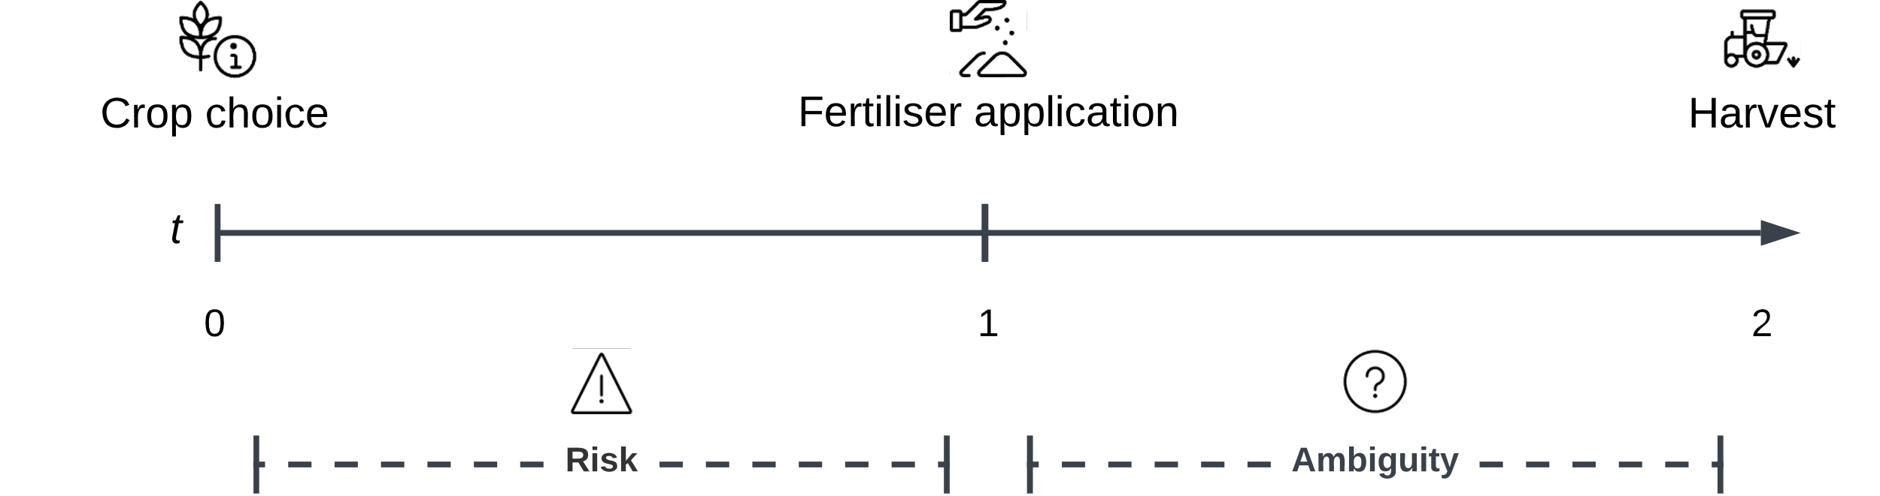
Figure 1. Economic decision framework

We consider a static model of a representative farmer who produces a single commodity (winter wheat) using a single input (synthetic N fertilizer). Expected farmer profits $\left(π\right)$ are defined as revenue minus costs:
$$\begin{aligned}π=p_{w}y\left(N\right)-p_{N}N\#\left(8\right)\end{aligned}$$
where $p_{w}$ is the wheat price, $y$ the expected yield, $p_{N}$ the fertilizer price, and $N$ the fertilizer quantity. We assume that, once the crop is determined at time $t_{0}$, the farmer knows the associated fertilizer needs for the season. All the volume is then either purchased at market price or through a forward contract. When farmers simply buy fertilizers close to application, they pay the stochastic spot price $\left({\tilde{p}}_{N,1}\right)$. When forward contracting, the input costs become fixed $\left(f\right)$, with the forward price calculated as:
$\begin{aligned}f=p_{N,0}e^{-rT}\#\left(9\right)\end{aligned}$where $p_{N,0}$ is the fertilizer spot price at $t_{0}$, $r$ is the risk-free rate, and $T$ is the delivery time. We also assume no fixed and variable costs (e.g., information gathering expenses or commissions) for entering the contract. We consider forward contracting as mathematically equivalent to a buy-and-hold strategy. If the input is bought at time $t_{0}$, the cost at time $t_{1}$ is the current spot price plus storage costs. With a forward contract, the firm instead commits to a purchase price $(f)$ that already reflects these same costs. Hence, forward contracting reproduces the same outcome as purchasing and store, while avoiding holding inventory. In this context we assume the cost of forward contracting for fertilizers to be zero.

contract design
In addition to the option of buying fertilizers at the spot price $\left({\tilde{p}}_{N,1}\right)$ and forward contracting with a supplier, thus fixing the price $\left(f\right)$, we introduce an “insurance” mechanism to the contract that sets a price ceiling. By paying a premium $\left(Γ\right)$, if the fertilizer price is above a certain threshold $\left(k\right)$, the insurance payoff $\left(I\right)$ would ensure that the price farmers pay for fertilizer would be capped. This mechanism thus functions as a European call option where the payout amount is made whenever the fertiliser spot price at time $t=1$ is above the farm's individual threshold price, otherwise the payout is zero:
$$\begin{aligned}I=\max{(p_{N,1}-k,0)} \#(10)\end{aligned}$$
In this case, and unlike the traditional forward contract, the contract is not free to enter. Here, the supplier carries all the risk and should thus be compensated. To calculate the premium of an European call option, we discount its expected payoff:
$$\begin{aligned}Γ=E(I)e^{-rT}\#(11)\end{aligned}$$
Traditional forward contracts primarily address risk aversion by fixing the price and eliminating exposure to future price volatility. In contrast, the proposed adjusted contract (also called maximum price contract) targets downside risk aversion and loss aversion by offering protection against adverse price movements while preserving the opportunity to benefit from price declines. Available purchasing choices are summarized in Table 1.
Table 1. Overview of traditional and adjusted contract design
 | Spot price | Forward contract | Adjusted contract
Fertilizer cost | $${\tilde{p}}_{N,1}$$ | $$p_{N,0}e^{-rT}$$ | $$\left\{\begin{aligned}p_{N,1}-k if p_{N,1}>k \\ p_{N,1} if{ p}_{N,1}≤k\end{aligned}\right.$$
Contract cost | - | - | $$Γ$$
Mechanism | - | Price fixing | Price ceiling
Behavior targeted | - | Risk aversion | Downside risk aversion/Loss aversion
Notes: we assume no cost of storage for the forward contract.

Profit functions
In our model farmers can choose whether to buy part or all their fertilizers needs through a forward contract or the adjusted contract. For a forward contract, farmers perceive the value of their contract choice as positive or negative (i.e. gain or loss) depending on whether they paid more or less than the underlying spot price. In this case, the payoff is calculated as:
$$\begin{aligned}Π_{F}=f-p_{N}\#\left(12\right)\end{aligned}$$
For the adjusted contract, a gain (loss) occurs when the payoff received from the insurance mechanism $(I)$ is greater (smaller) than the premium paid $(Γ)$. The adjusted contract benefits are then calculated as the payoff minus the premium paid:
$$\begin{aligned}Π_{I}=I-Γ\#\left(13\right)\end{aligned}$$
In the case of broad framing, profits are then defined as:
$$\begin{aligned}π_{BF}=p_{w}y\left(N\right)-p_{N}N+Π_{i}N\#\left(14\right)\end{aligned}$$
with $i=\left[0,F,I\right]$, in the case of no contract, forwards, or adjusted contract respectively. In the case of narrow framing, utility is narrowly defined by considering only the decision at hand:
$$\begin{aligned}π_{NF}=Π_{i}N\#\left(15\right)\end{aligned}$$

Methodology
In this section we present the different economic decision models, the biophysical and statistical approaches used to estimate the models, and the computation method of the adjusted contract price. For the decision under broad framing we first estimate the interactions between nitrogen application and crop yield, and the relationship between nitrogen and wheat prices. The data sources and the estimation will be discussed in the subsequent sections.

Nitrogen – yield relationship
We estimate nitrogen-yield relationships using data from the Environmental Policy Integrated Climate-based (EPIC; Williams 1995) crop model, where different level of nitrogen are used to simulate crop yield. Simulated observations of winter wheat yield for different levels of nitrogen applications are then used in a production function to estimate the statistical relationship between nitrogen and yield under risk. The estimation employed here, based on Just & Pope (1978, 1979), allows inputs to influence both the mean and the variability of outputs:
$$\begin{aligned}y(N)=f\left(N\right)+σ_{y}\left(N\right)ε\#\left(16\right)\end{aligned}$$
where $f\left(N\right)$ represents the expected yield (production function) and $σ_{y}\left(N\right)$ the standard deviation of yield (variation function), with the assumption that $E(ε)=0$ and $σ(ε)=1$. Following Finger & Hediger (2008), we employ a production function estimation of the form:
$$\begin{aligned}f\left(N\right)=β_{0}+β_{1}N^{0.5}+β_{2}N+e\#\left(17\right)\end{aligned}$$
If $β_{1}>0$ and $β_{2}<0$, the function shows decreasing marginal productivity of nitrogen, where yields are monotonically increasing up to some point of nitrogen use and then monotonically decreasing. We then define yield variation as the absolute difference between observed and expected yields (Finger & Schmid, 2008). Therefore, we regress residual from the production function estimation in (17) ($\hat{e}=y-\hat{y})$ to estimate the yield variation function, i.e. the relation between the level of nitrogen input and yield variance:
$$\begin{aligned}σ_{y}\left(N\right)=\left|\hat{e}\right|=β_{0}+β_{1}N^{0.5}\#\left(18\right)\end{aligned}$$
The production and yield variability function are estimated with the MM-estimator (Yohai, 1987) to reduce potential influences of outlying observations on estimation results (Finger, 2013).

Nitrogen-Yield prices relationship
To estimate the joint dynamic price processes of nitrogen $(p_{N})$ and wheat $(p_{w})$, we use a quantile vector autoregression (QVAR) and a copula approach (Li & Chavas, 2023). Stochastic price dynamics are represented by a general autoregressive process of the form:
$$\begin{aligned}p_{t}=\left[\begin{matrix}p_{N,t} \\ p_{w,t}\end{matrix}\right]=\left[\begin{matrix}g_{N}(p_{t-1},…,p_{t-n} \\ g_{w}(p_{t-1},…,p_{t-n}\end{matrix}\right]\#\left(19\right)\end{aligned}$$
where the distribution functions 𝑔(⋅) explain the contemporaneous prices through their lags. We are interested in the joint distribution function described as:
$$\begin{aligned}F\left(p | P_{t-1}\right)=Prob[g(p_{t-1},…,p_{t-n}≤p]\#\left(20\right)\end{aligned}$$
where $P_{t-1}=(p_{t-1},…,p_{t-n})$ includes lagged realizations of all prices. To estimate the joint distribution $F$, we first derive the marginal distribution functions using a QVAR model:
$$\begin{aligned}F_{N}\left(p_{N} | P_{t-1}\right)=Prob[g_{N}(p_{t-1},…,p_{t-n}≤p_{N}]\#\left(21a\right)\end{aligned}$$
$$\begin{aligned}F_{w}\left(p_{w} | P_{t-1}\right)=Prob[g_{w}(p_{t-1},…,p_{t-n}≤p_{w}]\#\left(21b\right)\end{aligned}$$
We then rely on Sklar’s theorem (Sklar, 1959), and use a copula $C$ (Nelsen, 2006) to estimate the following relationship:
$$\begin{aligned}F\left(p | P_{t-1}\right)=C\left[F_{N}\left(p_{N} | P_{t-1}\right),F_{w}\left(p_{w} | P_{t-1}\right)\right]\#\left(22\right)\end{aligned}$$

Adjusted contract pricing
We derive the contract pricing with a burn analysis. We implement this by determining the discounted average payoff of the contract over $n$ simulations. The general pricing formula (Eq. 11) is then implemented as follows:
$$\begin{aligned}Γ=\frac{1}{n}\sum_{t-1}^{n}{\left(I\right)}e^{-rT}\#\left(23\right)\end{aligned}$$
We specify the assumptions needed for the calculation following our decision framework (section 2.3). The planning horizon is set for one season, while the considered contract duration is six months (from crop choice/planting in early October to the first fertilizer application in early March). Different strike prices will be analyzed based on the price distribution, allowing for evaluation of contracts across different price protection threshold. A standard risk free interest rate of 3% is applied to discount future payoffs to present values.

Simulation of utility under different decision theories and framing
The described information on yield, price dynamics, and contract cost, enter the different economic models of farmers’ decision-making. Specifically, we analyse the impact on utility level for different decision theories and different framing. In the case farmers rely on a broad decision framing, Eq. (12) will be evaluated under EUT, CPT, and the α-EU frameworks. Under narrow framing, farmers profit are instead derived from Eq. (15). Given that no ambiguity arise under narrow framing, only EUT and CPT preferences are considered. A graphical summary of the methodological steps can be found in Figure X.
Figure X. Methodological diagram
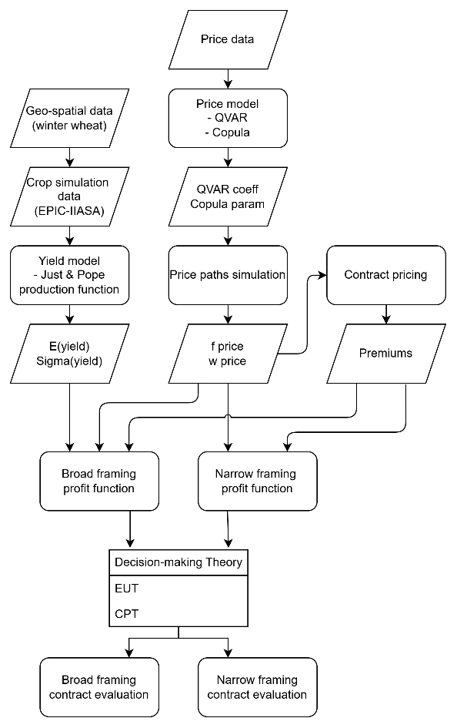

To conduct the simulation, assumptions regarding the representative farm characteristics, and the behavioural parameters entering the models have to be specified. For a German representative arable farm, average N fertilizer requirement are 200 kgN/ha, sowing is usually in late October, and harvest in early August (Hernández-Ochoa et al., 2023). Absolute risk aversion for the EUT specification $(δ)$ is considered between 0.00001 (less risk-averse) and 0.001 (more risk-averse). Structural parameter for CPT and $α$EU are derived from experimental evidence available in the literature. For the CPT model, final prospect values are dependent on risk aversion $(a)$, loss aversion $\left(λ\right)$, and probability distortion $\left(γ\right)$. Broad evidence on structural parameter elicitation is available for European farmers in general and German farmers in particular (Bougherara et al., 2017; Finger et al., 2024; Rommel et al., 2023). The considered parameters values are: $a=0.334$, $λ=1.574$, and $γ=0.571$. Alternative parametrization are considered for robustness checks. As reference points, we follow Kőszegi & Rabin (2007) argument to use expected outcomes in the case of broad framing (in our case expected profit per hectare), and zero for narrow framing. For the $α$EU, we consider a binary state space of either high or low profits occurring with probability $P$. Ambiguity arises as the farmer knows that $P$ lies in a certain interval $P=\left[P_{min},P_{max}\right]$ that we naively derive from profits distribution. The parameter for ambiguity aversion $(α)$ is considered to be $[0.1, 0.5, 0.9]$, reflecting ambiguity loving, neutrality, and aversion respectively (Couture et al., 2024).

Data
In this section we present: i) the dataset used to estimate the nitrogen-yield relationship, and ii) the price data. We obtained fertilizers and wheat prices farm level data for the Cologne Lowland area, in the southwest of the German Federal state of North Rhine-Westphalia. We thus focus our analysis of fertilizer-yield relationship on the same geographic area.

Yield data
We use data generated from the European implementation of the EPIC model (EPIC-IIASA; (Balkovič, 2025; Balkovič et al., 2013). Simulation Units from the EPIC model (Fig. Xa) were overlapped with winter wheat field (Fig. Xb), obtained from a crop type classification raster (Asam et al., 2022; Gessner et al., 2025), allowing us to retain only Simulation Units where winter wheat was cultivated in 2024. Representative locations across Germany were then randomly sampled for rural counties (Kreise/Landkreise) were winter wheat is one of the top 3 cultivated crop. For each of these counties the number of sampled locations is weighted by winter wheat share among the total cultivated area (Fig. Xc). Final sampled locations are displayed in Figure Xd.
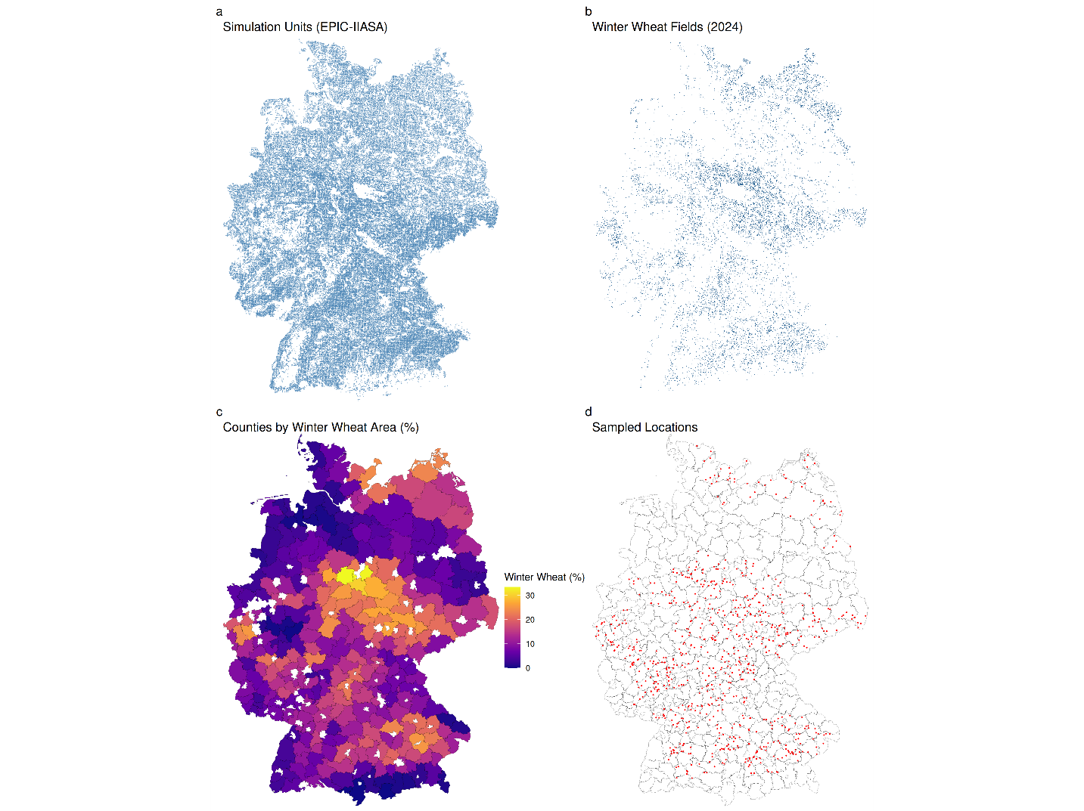
Figure X.
The dataset includes, for each sampled location, winter wheat yields for different levels of N applications, management practices and weather scenarios. Table 2 presents summary statistics of generated yield levels for different N application rates. It shows a linear relationship between N application rates and the level of wheat yield. Table A1 in the appendix shows complete descriptive statistics for the (EPIC-IIASA) simulated data.
Table 2. Summary statistics of simulated wheat yield (t//ha) from the EPIC-IIASA crop model
N application rate  (kgN/ha) | Median | Median of Absolute  Deviation (MAD)ª | Min | Max | Observations
10 | 1.6 | 0.18 | 1.16 | 2.31 | 35
50 | 3.65 | 0.69 | 2.02 | 4.65 | 140
100 | 5.76 | 0.87 | 3.05 | 7.15 | 140
180 | 7.83 | 1.01 | 4.30 | 14.01 | 1084
250 | 11.23 | 0.86 | 4.68 | 13.32 | 210
ª scaled by a correction factor of 1.4826

Price data
We use farm-level fertilizer and wheat prices data obtained from the Chamber of Agriculture of North Rhine-Westphalia. We use Calcium Ammonium Nitrate (CAN) as representative N-fertilizer that is widely applied and for which data is most complete. Prices for CAN are recorded twice a month (1st and 3rd Monday of the month), while the wheat price time series contains weekly observations. We thus only use wheat price observations in weeks for which we have also fertilizer price recordings. We detected outliers following the Chen & Liu (1993) procedure (see Figure A1 in the appendix). The final dataset consists of 401 biweekly (twice per month) observations of CAN and wheat prices from January 2009 to November 2025 (Figure 2). For the analysis we use the first difference as both CAN and wheat time series are not stationary (see Table A2 in the appendix).
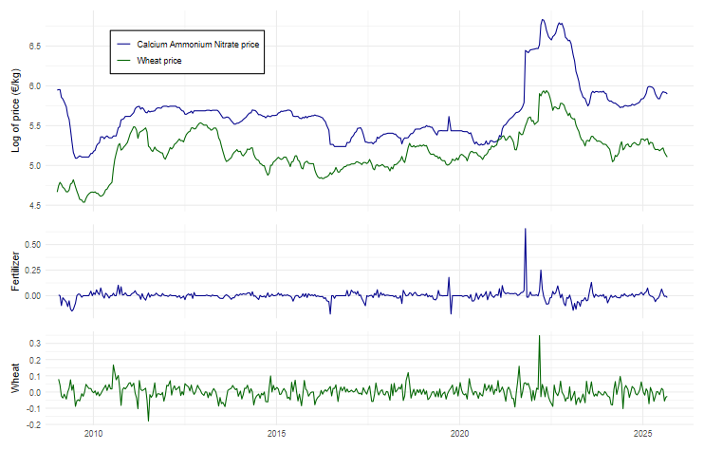
Figure 2. Calcium Ammonium Nitrate (CAN) and wheat log of prices (€/kg; Jan 2009-Nov 2025).

Econometric estimation

Production and yield variation functions
The estimations of the production and yield variation functions are presented in Table 3. Variables to control for land and water management are included. Coefficient estimates of the production function indicate that N application does not display diminishing marginal productivity ($β_{N}>0$ within the observed application range) and might be due to the model simulating only optimal nitrogen application levels. The variation function shows that yield variability (i.e. production risk) increases with higher nitrogen applications. Stochastic yield for our representative winter wheat farmer in the study region are simulated based on the estimated coefficients, assuming rainfed wheat and conventional tillage.
Table 3. Estimation of production (Eqs. 17) and variation (Eqs. 18) functions
 | Production function | Variation function
Intercept | -0.464** | 0.087
 | (0.205) | (0.116)
N^{0.5} | 0.284*** | 0.081***
 | (0.049) | (0.025)
N | 0.026*** | -0.003**
 | (0.003) | (0.001)
irrigation | 0.118* | -0.053
 | (0.069) | (0.039)
til_min_cons | -1.596*** | -0.040
 | (0.072) | (0.044)
til_contill_r00 | 1.013*** | -0.243***
 | (0.061) | (0.035)
til_contill_r30 | 0.632*** | -0.042
 | (0.093) | (0.051)
til_contill_r60 | 0.407** | 0.226***
 | (0.167) | (0.062)
til_contill_r90 | 0.030 | 0.355***
 | (0.196) | (0.075)
Num.Obs. | 1609 | 1609
R2 | 0.864 | 0.098
R2 Adj. | 0.863 | 0.093
Note: til_min_cons: dummy indicating minimum tillage with high crop residues left in the field; til_contill_r: dummies indicating conventional tillage with different level of crop residues left in the field (0, 30, 60, and 90%); statistics in parentheses are standard errors; significance at * = 0.1, ** = 0.05, and *** = 0.01 levels.

Price distributions
We use QVAR to estimate the marginal distributions (21 a-b). To determine the number of lags, we use the Schwarz Bayesian Information Criterion (BIC). As suggested by the BIC, a model of order 1 was selected for parsimony. The QVAR specification allows price dependencies to be different across price quantiles. The estimation is thus carried out for each integer quantile $q$ from 1 to 99 (Koenker, 2005), with the following specification:
$$\begin{aligned}p_{N}\left(q_{N} | P_{t-1}\right)=β_{0, N}\left(q_{N}\right)+β_{1, N}\left(q_{N}\right)P_{t-1}\#\left(24a\right)\end{aligned}$$
$$\begin{aligned}p_{w}\left(q_{w} | P_{t-1}\right)=β_{0, w}\left(q_{w}\right)+β_{1, w}\left(q_{w}\right)P_{t-1}\#\left(24b\right)\end{aligned}$$
where $β_{0, i}(q_{i})$, with $i∈\{N,w\}$, describes the intercept for price $p_{i}$ in quantile $q_{i}$ and $β_{1, i}(q_{i})P_{t-1}$ is a matrix of parameters for the conditional effect of each lag and quantile. We investigate various functional specifications of the QVAR mode by comparing information criteria on the mean regression (VAR). Results of the estimation of the VAR and QVAR for selected quantiles ($q$ = 0.1, 0.3, 0.5, 0.7, 0.9) are reported in Table 4 and Table 5. Standard errors are derived by bootstrapping (Koenker & Xiao, 2006), and the goodness of fit for the QVAR is calculated following Koenker & Machado (1999).
Results indicate that price changes for CAN are correlated to the lag of own price changes and mostly correlated to the lag of wheat price changes, but more around the central quantiles. Price changes for wheat are correlated to own lagged price changes only at the median, while correlation to lagged changes in CAN show more statistical significance. The pseudo R² calculated for the QVAR indicate a low goodness of fit for both CAN and wheat prices, showing that little variation in price changes are explained in the model. In general, effects vary across quantile showing stronger effects in the median regression, dissipating in the tails.

Table 4. VAR and QVAR estimates for Calcium Ammonium Nitrate price
 |  |  | $$p_{N}$$
 | VAR |  |  | QVAR
Quantiles |  | 0.1 | 0.3 | 0.5 | 0.7 | 0.9
Intercept | -0.000 | -0.033*** | -0.009*** | 0.000 | 0.009*** | 0.030***
 | (0.002) | (0.004) | (0.002) | (0.001) | (0.002) | (0.005)
$$p_{N,t-1}$$ | 0.220*** | 0.391*** | 0.309*** | 0.252*** | 0.243*** | 0.201**
 | (0.048) | (0.029) | (0.038) | (0.033) | (0.056) | (0.102)
$$p_{w,t-1}$$ | 0.206*** | -0.041 | 0.075** | 0.051*** | 0.113** | 0.230*
 | (0.056) | (0.080) | (0.036) | (0.020) | (0.036) | (0.082)
Num.Obs. | 396 | 396 | 396 | 396 | 396 | 396
Adj. R² | 0.197
Pseudo R² |  | 0.094 | 0.073 | 0.034 | 0.053 | 0.061
RMSE | 0.05 | 0.06 | 0.05 | 0.05 | 0.05 | 0.06
Note: quantile regression standard errors are calculated by bootstrapping; stars indicate significance at * = 0.1, ** = 0.05, and *** = 0.01 levels; Pseudo R² for quantile regression are calculated following Koenker & Machado (1999).

Table 5. VAR and QVAR estimates for wheat price
 |  |  | $$p_{w}$$
 | VAR |  |  | QVAR
Quantiles |  | 0.1 | 0.3 | 0.5 | 0.7 | 0.9
Intercept | 0.001 | -0.050*** | -0.017*** | 0.000 | 0.016*** | 0.045***
 | (0.002) | (0.004) | (0.002) | (0.002) | (0.002) | (0.005)
$$p_{N,t-1}$$ | 0.075* | 0.130 | 0.082*** | 0.071*** | 0.055 | 0.037
 | (0.042) | (0.133) | (0.026) | (0.014) | (0.073) | (0.111)
$$p_{w,t-1}$$ | 0.228*** | 0.150 | 0.234*** | 0.224*** | 0.233*** | 0.246**
 | (0.049) | (0.100) | (0.052) | (0.048) | (0.054) | (0.107)
Num.Obs. | 396 | 396 | 396 | 396 | 396 | 396
Adj. R² | 0.061
Pseudo R² |  | 0.029 | 0.048 | 0.039 | 0.032 | 0.026
RMSE | 0.04 | 0.07 | 0.05 | 0.04 | 0.04 | 0.06
Note: quantile regression standard errors are calculated by bootstrapping; stars indicate significance at * = 0.1, ** = 0.05, and *** = 0.01 levels; Pseudo R² for quantile regression are calculated following Koenker & Machado (1999).

The estimations of the marginal distributions are used to evaluate the joint distribution. We estimate $F_{N}$ and $F_{w}$ by first deriving the quantiles that provide the best fit for the estimation. The obtained quantile distributions are used to estimate the copula connecting the marginal distributions. The copula $C\left(F_{w} | F_{N}\right)$ indicates the contemporaneous co-dependence between the marginal distributions. It is estimated using a quantile regression on the inverse marginal distributions using a conditional distribution function $\left(D\right)$ of the form:
$$\begin{aligned}D\left(q_{w} | q_{N}\right)=β_{0}\left(q_{w}\right)+β_{1}\left(q_{w}\right)q_{N}\#\left(25\right)\end{aligned}$$
Results displayed in Table 6 clearly show that the quantile copula linking the conditional distributions of wheat and fertilizer price changes shows no statistically significant dependence. The slope coefficients are not significant at any of the estimated quantiles and the intercept estimates closely approximate the quantile itself. This indicate that the estimated copula is approximately the independence copula and fertilizer and wheat price relationship is fully captured by the QVAR model. Since considering the conditional distribution provides no additional information, we use the marginal distributions to simulate the price paths.
Table 6. Quantile estimation of conditional copula
 |  |  | $$q_{w}$$
 | 0.1 | 0.3 | 0.5 | 0.7 | 0.9
Intercept | 0.079*** | 0.247*** | 0.489*** | 0.700*** | 0.900***
 | (0.033) | (0.050) | (0.047) | (0.041) | (0.027)
$$q_{N}$$ | 0.042 | 0.105 | 0.014 | 0.000 | 0.000
 | (0.056) | (0.093) | (0.078) | (0.072) | (0.048)
Note: $q_{w}$ and $q_{N}$ denote the quantile distribution of wheat and CAN. Standard Errors in parenthesis are calculated by bootstrapping; stars indicate significance at * = 0.1, ** = 0.05, and *** = 0.01 levels.

Results

Contract pricing
We simulate 1.000 price paths of 24 time periods (one year). Simulations for CAN and wheat prices based on the estimated models (see also Fig. A1 for density distributions) are used for the contract pricing and profits calculations. Results from the burn analysis at different strike prices are presented in Table 7. We select the strike prices based on distribution quantiles of simulated CAN and wheat prices. Diminishing premiums at higher strike prices reflecting lower probability of exercise and expected payoff.

Table 7. Contract pricing by burn analysis at different strike prices
 | CAN |  |  | Wheat
Quantile | Strike price (€/kg) | Premium (€/kg) | Quantile | Strike price (€/kg) | Premium (€/kg)
0.5 | 0.355 | 0.011
0.6 | 0.361 | 0.009
0.7 | 0.366 | 0.007
0.8 | 0.375 | 0.004
0.9 | 0.389 | 0.002

Profits and Utility levels
Based on our decision framework, we assume that the decision-maker can adopt a forward contract at the start of the season, thus fixing the CAN price, or adopt the adjusted contract with different price caps. Alternatively, CAN is bought in early march at market price (no contract). Simulated profits for the different strategies are calculated under broad and narrow framings (see Annex 3 for summary statistics). Results are displayed in Table 8 and Table 9 for EUT and CPT preferences under broad framing, and in Table 10 and Table 11. EUT results are reported as Certainty Equivalents (CE) in Euro/ha across different values of absolute risk aversion $(δ)$. CPT results are reported as final prospect values $(V)$. Alternative parameter levels for risk aversion $(a)$, loss aversion $\left(λ\right)$ and probability decision weights $\left(γ\right)$ are included. The choice of the reference point is different for broad and narrow framing. When the contract is considered as a risk management tool, we adopt expected outcome as a reference point. When it is considered as a stand-alone investment, the reference point is zero.
Under broad framing, the producer evaluates each contract in the context of the entire farm profits. Results for the EUT framework suggest that across all levels of risk aversion (except for extremely risk averse levels), the adjusted contract delivers the highest CE, indicating the viability of this strategy when framed as a risk management tool. In general, however, the differences in CEs are small across the different strategies. Interestingly, the forward contract yields the lowest CE across all the \delta values, indicating that, under broad framing, this would be the least preferred strategy. This is explained by the fact that by fixing input prices, the producer is losing the natural price hedge (i.e. given the correlation between fertilizers and wheat prices, when prices are high farmers get higher output prices and pay higher input prices, the contrary happens when prices are low). This causes total profits to fluctuate more strongly.
Results for the broad framing using a CPT framework display negative values for all the strategies, meaning that the prospects are perceived as a loss relative to the expected profits under the forward contract. This is consistent across alternative parametrization with the only exception for the atypical case of loss-seeking behavior $\left(λ=0.5\right)$. This suggests that the adjusted contract is not attractive to farmers when considering CPT preferences, in contrast to EUT results.
When the contracts are narrowly framed as risky investments, producers consider only the contract’s payoff and cost, with the reference point becoming zero. Here, since it is framed as an investment decision, the “no contract” strategy is not analyzed. Results for the EUT framework indicate that forward pricing yield the highest CE values across the different risk aversion levels. This result stands in direct contrast to the broad framing scenario. Under narrow framing, profit variability is driven solely by fertilizer price risk. In contrast, under broad framing, the correlation between fertilizer and wheat prices makes the adoption of a price-fixing strategy unattractive to farmers, as it eliminates the natural price hedge. Consequently, while forward contracts are disfavored under broad framing, they are preferred under narrow framing. Similar to the broad framing case, results for the CPT framework display negative values. Overall, both EUT and CPT results under narrow framing suggest that the adjusted contract is not a viable option and might face low adoption.

Table 8. Certainty Equivalents (CE) for different level of absolute risk aversion $(δ)$ under broad framing.
 | No contract | Forward contract |  |  | Adjusted contract
Strike | - | - | 0.355 | 0.361 | 0.368 | 0.376 | 0.388
$δ$= 0.00001 | 1162.43 | 1160.01 | 1162.31 | 1162.57 | 1162.95 | 1162.21 | 1162.41
$δ$ = 0.00005 | 1160.47 | 1157.96 | 1160.29 | 1160.56 | 1160.95 | 1160.22 | 1160.43
$δ$ = 0.0001 | 1158.02 | 1155.38 | 1157.77 | 1158.05 | 1158.45 | 1157.73 | 1157.95
$δ$ = 0.0005 | 1138.43 | 1134.79 | 1137.57 | 1137.94 | 1138.44 | 1137.80 | 1138.14
$δ$ = 0.001 | 1113.95 | 1109.05 | 1112.32 | 1112.81 | 1113.42 | 1112.90 | 1113.37
Note: CE in EUR/ha; the highest CE for each risk aversion level is highlighted in bold.

Table 9. CPT results under broad framing
 | No contract | Forward contract |  |  | Adjusted contract
Strike | - | - | 0.355 | 0.361 | 0.368 | 0.376 | 0.388
$$a=0.334; λ=1.574; γ=0.571$$ | -2.43 | -2.48 | -2.44 | -2.42 | -2.44 | -2.46 | -2.45
$$a=0.1$$ | -0.47 | -0.48 | -0.48 | -0.48 | -0.48 | -0.48 | -0.48
$$a=0.5$$ | -7.18 | -7.37 | -7.21 | -7.16 | -7.19 | -7.23 | -7.23
$$λ=0.5$$ | 0.93 | 0.92 | 0.93 | 0.95 | 0.93 | 0.91 | 0.91
$$λ=2$$ | -3.76 | -3.83 | -3.78 | -3.76 | -3.78 | -3.79 | -3.79
$$γ=0.4$$ | -2.86 | -2.92 | -2.89 | -2.86 | -2.89 | -2.91 | -2.91
$$γ=0.7$$ | -2.25 | -2.30 | -2.26 | -2.25 | -2.26 | -2.27 | -2.27
Note: the assumed reference point is the forward contract expected outcome.

Table 10. Certainty Equivalents (CE) for different level of absolute risk aversion $(δ)$ under narrow framing.
 | Forward contract |  |  | Adjusted contract
Strike | - | 0.355 | 0.361 | 0.368 | 0.376 | 0.388
$δ$= 0.00001 | 2.39 | -0.1 | 0.15 | 0.53 | -0.21 | -0.02
$δ$ = 0.00005 | 2.38 | -0.11 | 0.15 | 0.53 | -0.21 | -0.02
$δ$ = 0.0001 | 2.37 | -0.11 | 0.15 | 0.53 | -0.22 | -0.02
$δ$ = 0.0005 | 2.29 | -0.15 | 0.12 | 0.51 | -0.23 | -0.03
$δ$ = 0.001 | 2.18 | -0.19 | 0.08 | 0.48 | -0.25 | -0.04
Note: CE in Euro/ha; the highest CE for each level of risk aversion is highlighted in bold.
Table 11. CPT results under narrow framing
 | Forward contract | Adjusted contract
Strike | - | 0.355 | 0.361 | 0.368 | 0.376 | 0.388
$$a=0.334; λ=1.574; γ=0.571$$ | -0.74 | -0.88 | -0.90 | -0.85 | -1.03 | -0.99
$$a=0.1$$ | -0.15 | -0.53 | -0.60 | -0.69 | -0.86 | -1.01
$$a=0.5$$ | -1.72 | -1.21 | -1.13 | -0.93 | -1.11 | -0.91
$$λ=0.5$$ | 0.52 | 0.26 | 0.19 | 0.16 | 0.03 | -0.05
$$λ=2$$ | -1.24 | -1.33 | -1.33 | -1.25 | -1.45 | -1.37
$$γ=0.4$$ | -1.15 | -0.79 | -0.79 | -0.68 | -0.81 | -0.76
$$γ=0.7$$ | -0.51 | -0.98 | -1.01 | -0.99 | -1.2 | -1.15
Note: the assumed reference point is zero.

Standard EUT assumes the decision-maker knows the exact probability distribution over outcomes. The α-EU model (Ghirardato et al., 2004) relaxes this by assuming the agent faces ambiguity: they don't know the true probability, only that it lies within a set of plausible distributions (a "prior set" P). We thus consider an ambiguous context in which the farmer only knows that the probability of low profits lies in a certain interval P=pmin,pmax. The size of P represent subjective ambiguity. For analysis purposes, we make ambiguity objective by simulating different ambiguity sets. For each set, different values of risk aversion () and ambiguity preferences (α) are explored. Ambiguity averse α=0.9, ambiguity neutral α=0.5, and ambiguity loving α=0.1 behavior are analyzed.

Discussion
Our results highlight meaningful differences in how producers evaluate input price risk-management tools, particularly when considered through the different lenses of broad and narrow framing. Under broad framing, the contract is assessed as part of the producer’s overall farm portfolio, leading to choices that reflect improvements in total profits. In contrast, narrow framing focuses on the contract in isolation, considering only its standalone payoff and cost structure. The observed variation in results outcomes suggests that producers’ contract decisions depend not only on the underlying decision theory but also on the cognitive frame through which the decision is made, as suggested by findings on crop insurance (Babcock, 2015; Dalhaus et al., 2020). Except for limited evidence of EUT values under broad framing, the results suggests that, under both framing, the adjusted contract leads to no meaningful improvement for input price risk. A more holistic approach that considers both input and output price risk might be better suited.
The results from the Quantile Vector Autoregression (QVAR) combined with a copula allowed us to investigate the structure of the multivariate distribution of Calcium Ammonium Nitrate (CAN) and wheat prices. We find positive correlations between price changes and changes in their own and cross lagged changes, especially around the median, with the correlation fading for lower and higher quantiles of the price distribution. This approach allowed us to consider the dependency of the two prices on each other in the forecast model. Nonetheless, simulated prices for CAN present a shifted price distribution (Fig. A1), implying that our forecasted prices present higher average values than the observed empirical distribution. This might bias our quantitative results, but since we base both the contract pricing and the profit calculation on forecasted prices, the qualitative interpretation does not lose validity.
The stochastic simulation incorporates also production risk through the estimation of a stochastic production function. We use data from the EPIC-IIASA crop model that simulates yield levels for specific spatial coordinates, that allows the site specific modelling employed here. However, a drawback of the data we use is that the crop model underestimate average winter wheat yields and their standard deviation (Balkovič et al., 2013). This implies that we might underestimate total profits and production risk in the broad framing calculations. It is important to note also that only yields from an optimal nitrogen application range are simulated. This implies that our stochastic production function estimation does not capture diminishing marginal productivity of fertilizers. Nonetheless, we assume that our representative farm applies an optimal N fertilizer level, mitigating the implication of the biased estimation. Our methodology is able to model price dependencies, but does not capture wheat yield and wheat price correlation (i.e. the level of “natural hedge”). This omission is unlikely to materially affect results, given our focus on a small production region where local shocks do not exert measurable feedback effects on price formation.
Lastly a note on our modelling approach, decision theories models, and parameters specifications is needed. First, we restricted our analysis on a single agricultural activity (winter wheat production) and assumed no other costs beside input prices. This simplification was employed for analysis purposes but might not reflect the complexity of real word farming activities. In addition, strategies to reduce dependency on nitrogen fertilizers and fertilizers saving technologies, can also have the dual benefit of reducing input price risk and environmental impact (Krein et al., 2023).
The EUT preferences are evaluated using the Mean-Variance (M-V) approximation (Eq. 1). This model has been widely used in the literature for its simplicity and easy interpretation, especially for hedging decisions (Spada et al., 2025). Nonetheless, this approach has been criticized as imposes restrictive behavioral assumption such as the independence to wealth levels, and the reliance on only the first two moment of the outcome distribution. Moreover, the selected coefficients may not fully cover the range of farmers attitudes, affecting in turn the interpretation of our results. Thus, while this framework facilitates the tractability, it may not fully capture the heterogeneity and wealth-dependent nature of actual farmers behavior.
A similar argument can be made for CPT preferences. First, final prospect values heavily depends on the model specification and references point. Further, heterogeneity and instability of the parameters also affect results (Finger et al., 2024). The parameters employed in the analysis have been taken from empirical evidence on German farmers (Rommel et al., 2023) and robustness to alternative parametrization has been explored, indicating similar results. It is worth noting anyway that our point estimates might not reflect well the heterogeneity in elicited parameter that farmers display. In addition, externally imposed reference points have been frequently criticized (Kőszegi & Rabin, 2006, 2007). Producer reference points are unobservable, they can be highly heterogeneous among farmers and shift in time. Consequently, the results must be interpreted with caution given the sensitivity to the selected parameters and reference points.

Conclusions
In summary, we propose a maximum-price adjustment to a forward contract for input price risk management. This adjustment can better align to producers' actual behavioral preferences, thus making it more attractive to farmers. We estimate both production risk, using a stochastic production function, and price risk, by providing evidence on the quantile correlation between fertilizer and wheat prices. We use the estimated risks in a Montecarlo simulation to assess the feasibility of the introduction of the adjusted forward contract for input price risk management. This approach enables us to simulate price and production risk for utility levels calculations under different decision theories and framing scenarios.
We evaluate the adjusted contracts using Mean-Variance values under Expected Utility Theory and prospect values under Cumulative Prospect Theory. We also evaluate the outcomes under different decision framing: producers might frame the adoption of the contract in the context of a whole farm decision, considering it as a risk management tool (broad framing); alternatively, producers might narrowly frame the adoption as a standalone investment decision, considering it, in fact, as an investment. Results from the Montecarlo simulation, that incorporates both production and price risk, indicate that the contract delivers limited utility gains for farmers under broad framing, and that is not attractive when considered under narrow framing, suggesting that its real-word attractiveness may be low and that adoption could be limited if the contract were introduced.

References
Asam, S., Gessner, U., Almengor González, R., Wenzl, M., Kriese, J., & Kuenzer, C. (2022). Mapping Crop Types of Germany by Combining Temporal Statistical Metrics of Sentinel-1 and Sentinel-2 Time Series with LPIS Data. Remote Sensing, 14(13), 2981. https://doi.org/10.3390/rs14132981
Babcock, B. A. (2015). Using cumulative prospect theory to explain anomalous crop insurance coverage choice. American Journal of Agricultural Economics, 97(5), 1371–1384. https://doi.org/10.1093/ajae/aav032
Balkovič, J. (2025). LAMASUS - Simulated Crop Yields and Fertilizer Application Rates for Nine Crops under Six Management Intensity Scenarios in the EU [Dataset]. Zenodo. https://doi.org/10.5281/zenodo.17119992
Balkovič, J., van der Velde, M., Schmid, E., Skalský, R., Khabarov, N., Obersteiner, M., Stürmer, B., & Xiong, W. (2013). Pan-European crop modelling with EPIC: Implementation, up-scaling and regional crop yield validation. Agricultural Systems, 120, 61–75. https://doi.org/10.1016/j.agsy.2013.05.008
Barberis, N., Huang, M., & Thaler, R. H. (2006). Individual Preferences, Monetary Gambles, and Stock Market Participation: A Case for Narrow Framing. American Economic Review, 96(4), 1069–1090. https://doi.org/10.1257/aer.96.4.1069
BKG. (2025). Administrative areas 1:5000000, as at 31.12. (VG5000 31.12.) [Dataset]. https://gdz.bkg.bund.de/index.php/default/digitale-geodaten/verwaltungsgebiete/verwaltungsgebiete-1-5-000-000-stand-31-12-vg5000-12-31.html
Bocquého, G., Jacquet, F., & Reynaud, A. (2014). Expected utility or prospect theory maximisers? Assessing farmers’ risk behaviour from field-experiment data. European Review of Agricultural Economics, 41(1), 135–172. https://doi.org/10.1093/erae/jbt006
Bougherara, D., Gassmann, X., Piet, L., & Reynaud, A. (2017). Structural estimation of farmers’ risk and ambiguity preferences: A field experiment. European Review of Agricultural Economics, 44(5), 782–808. https://doi.org/10.1093/erae/jbx011
Chen, C., & Liu, L.-M. (1993). Joint Estimation of Model Parameters and Outlier Effects in Time Series. Journal of the American Statistical Association, 88(421), 284–297. https://doi.org/10.1080/01621459.1993.10594321
Couture, S., Lemarié, S., Teyssier, S., & Toquebeuf, P. (2024). The value of information under ambiguity: A theoretical and experimental study on pest management in agriculture. Theory and Decision, 96(1), 19–47. https://doi.org/10.1007/s11238-023-09942-y
Dalhaus, T., Barnett, B. J., & Finger, R. (2020). Behavioral weather insurance: Applying cumulative prospect theory to agricultural insurance design under narrow framing. PLOS ONE, 15(5), e0232267. https://doi.org/10.1371/journal.pone.0232267
Dong, F., Beckman, J., & Arita, S. (2025). Unraveling demand and supply shocks in the U.S. nitrogen market. Applied Economic Perspectives and Policy, n/a(n/a). https://doi.org/10.1002/aepp.70004
European Commission. (2022). Food security: The Commission addresses the availability and affordability of fertilisers in the EU and globally [Press release]. https://ec.europa.eu/commission/presscorner/detail/en/ip_22_6564
FAO. (2024). Inorganic fertilizers—2002-2022 (FAOSTAT Analytical Brief No. 90). https://doi.org/10.4060/cd1485en
Finger, R. (2012). Nitrogen use and the effects of nitrogen taxation under consideration of production and price risks. Agricultural Systems, 107, 13–20. https://doi.org/10.1016/j.agsy.2011.12.001
Finger, R. (2013). Investigating the performance of different estimation techniques for crop yield data analysis in crop insurance applications. Agricultural Economics, 44(2), 217–230. https://doi.org/10.1111/agec.12005
Finger, R., Garcia, V., McCallum, C., & Rommel, J. (2024). A note on European farmers’ preferences under cumulative prospect theory. Journal of Agricultural Economics, 75(1), 465–472. https://doi.org/10.1111/1477-9552.12565
Finger, R., & Hediger, W. (2008). The Application of Robust Regression to a Production Function Comparison. The Open Agriculture Journal, 2(1). https://doi.org/10.2174/1874331500802010090
Finger, R., & Schmid, S. (2008). Modeling agricultural production risk and the adaptation to climate change. Agricultural Finance Review, 68(1), 25–41. https://doi.org/10.1108/00214660880001217
Gessner, U., Hirner, A., Asam, S., Wenzl, M., & Kuenzer, C. (2025). Combining Machine Learning and Spatiotemporal Filtering to Map Crop Types of Germany for Seven Years. IEEE Geoscience and Remote Sensing Letters, 22, 1–5. https://doi.org/10.1109/LGRS.2025.3587517
Ghirardato, P., Maccheroni, F., & Marinacci, M. (2004). Differentiating ambiguity and ambiguity attitude. Journal of Economic Theory, 118(2), 133–173. https://doi.org/10.1016/j.jet.2003.12.004
Gilboa, I., & Schmeidler, D. (1989). Maxmin expected utility with non-unique prior. Journal of Mathematical Economics, 18(2), 141–153. https://doi.org/10.1016/0304-4068(89)90018-9
Hardaker, J. B., Huirne, R. B. M., Anderson, J. R., & Lien, G. (2015). Coping With Risk in Agriculture (3rd ed.). CABI Publishing. https://www.cabidigitallibrary.org/doi/book/10.1079/9781780645742.0000
Hernández-Ochoa, I. M., Gaiser, T., Hüging, H., & Ewert, F. (2023). Yield components and yield quality of old and modern wheat cultivars as affected by cultivar release date, N fertilization and environment in Germany. Field Crops Research, 302, 109094. https://doi.org/10.1016/j.fcr.2023.109094
IFA. (2022). Fertilizer use by crop and country for the 2017-2018 period. International Fertilizer Association (IFA). https://www.ifastat.org/consumption/fertilizer-use-by-crop
Just, R. E., & Pope, R. D. (1978). Stochastic specification of production functions and economic implications. Journal of Econometrics, 7(1), 67–86. https://doi.org/10.1016/0304-4076(78)90006-4
Just, R. E., & Pope, R. D. (1979). Production Function Estimation and Related Risk Considerations. American Journal of Agricultural Economics, 61(2), 276–284. https://doi.org/10.2307/1239732
Knight, F. H. (1921). Risk, uncertainty and profit (Vol. 31). Houghton Mifflin.
Koenker, R. (2005). Quantile Regression. Cambridge University Press. https://doi.org/10.1017/CBO9780511754098
Koenker, R., & Machado, J. A. F. (1999). Goodness of Fit and Related Inference Processes for Quantile Regression. Journal of the American Statistical Association, 94(448), 1296–1310. https://doi.org/10.1080/01621459.1999.10473882
Koenker, R., & Xiao, Z. (2006). Quantile Autoregression. Journal of the American Statistical Association, 101(475), 980–990. https://doi.org/10.1198/016214506000000672
Kőszegi, B., & Rabin, M. (2007). Reference-Dependent Risk Attitudes. American Economic Review, 97(4), 1047–1073. https://doi.org/10.1257/aer.97.4.1047
Krein, D. D. C., Rosseto, M., Cemin, F., Massuda, L. A., & Dettmer, A. (2023). Recent trends and technologies for reduced environmental impacts of fertilizers: A review. International Journal of Environmental Science and Technology, 20(11), 12903–12918. https://doi.org/10.1007/s13762-023-04929-2
Li, J., & Chavas, J. P. (2023). A dynamic analysis of the distribution of commodity futures and spot prices. American Journal of Agricultural Economics, 105(1), 122–143. https://doi.org/10.1111/ajae.12309
Mattos, F., Garcia, P., & Pennings, J. M. E. (2008). Probability weighting and loss aversion in futures hedging. Journal of Financial Markets, 11(4), 433–452. https://doi.org/10.1016/j.finmar.2008.04.002
Moritz, L., Spada, R., Rommel, J., Dalhaus, T., & Cerroni, S. (2026). Risk preferences and other (ignored) behavioral factors in fertilizer management decisions: A systematic literature review. Journal of Behavioral and Experimental Economics, 121, 102524. https://doi.org/10.1016/j.socec.2026.102524
Nelsen. (2006). An Introduction to Copulas. Springer. https://doi.org/10.1007/0-387-28678-0
O’Neill, B. C., Kriegler, E., Riahi, K., Ebi, K. L., Hallegatte, S., Carter, T. R., Mathur, R., & van Vuuren, D. P. (2014). A new scenario framework for climate change research: The concept of shared socioeconomic pathways. Climatic Change, 122(3), 387–400. https://doi.org/10.1007/s10584-013-0905-2
Prelec, D. (1998). The Probability Weighting Function. Econometrica, 66(3), 497–527. https://doi.org/10.2307/2998573
Rommel, J., Sagebiel, J., Baaken, M. C., Barreiro-Hurlé, J., Bougherara, D., Cembalo, L., Cerjak, M., Čop, T., Czajkowski, M., Espinosa-Goded, M., Höhler, J., Kuhfuss, L., Lagerkvist, C.-J., Lapierre, M., Lefebvre, M., Matzdorf, B., Ott, E., Paparella, A., Quendler, E., … Zagórska, K. (2023). Farmers’ risk preferences in 11 European farming systems: A multi-country replication of Bocquého et al. (). Applied Economic Perspectives and Policy, 45(3), 1374–1399. https://doi.org/10.1002/aepp.13330
Sklar, M. (1959). Fonctions de Répartition À N Dimensions Et Leurs Marges. Université Paris 8. https://books.google.nl/books?id=nreSmAEACAAJ
Spada, R., Moritz, L., Rommel, J., Cerroni, S., Meuwissen, M. P. M., & Dalhaus, T. (2025). Behavioral Preferences Affecting the Adoption of Financial Price Risk Management Tools in Agriculture: A Systematic Literature Review. https://doi.org/10.22004/ag.econ.356632
Tversky, A., & Kahneman, D. (1981). The Framing of Decisions and the Psychology of Choice. Science, 211(4481), 453–458. https://doi.org/10.1126/science.7455683
Tversky, A., & Kahneman, D. (1992). Advances in prospect theory: Cumulative representation of uncertainty. Journal of Risk and Uncertainty, 5(4), 297–323. https://doi.org/10.1007/BF00122574
Yohai, V. J. (1987). High Breakdown-Point and High Efficiency Robust Estimates for Regression. The Annals of Statistics, 15(2), 642–656. https://doi.org/10.1214/aos/1176350366

Appendix
Table A1 Descriptive statistics for simulated yield data
variable | mean | sd | min | max
N (kg/ha) | 167.17 | 55.97 | 10 | 250
yield (t/ha) | 7.39 | 2.25 | 1.16 | 14.01
historical weather | 0.53 | - | 0 | 1
cmip6_ipsl_ssp126 | 0.12 | - | 0 | 1
cmip6_ipsl_ssp585 | 0.12 | - | 0 | 1
cmip6_mpi_ssp126 | 0.12 | - | 0 | 1
cmip6_mpi_ssp585 | 0.12 | - | 0 | 1
rainfed | 0.86 | - | 0 | 1
irrigated | 0.14 | - | 0 | 1
rot_mono | 0.33 | - | 0 | 1
rot_1 | 0.15 | - | 0 | 1
rot_2 | 0.07 | - | 0 | 1
rot_3 | 0.07 | - | 0 | 1
rot_4 | 0.15 | - | 0 | 1
rot_6 | 0.08 | - | 0 | 1
rot_7 | 0.15 | - | 0 | 1
til_bau | 0.57 | - | 0 | 1
til_min_cons | 0.1 | - | 0 | 1
til_contill_r00 | 0.11 | - | 0 | 1
til_contill_r30 | 0.07 | - | 0 | 1
til_contill_r60 | 0.09 | - | 0 | 1
til_contill_r90 | 0.07 | - | 0 | 1
Note: outputs from different climate models based on phase 6 of the Coupled Model Intercomparison Project (cmip6) from the Institut Pierre-Simone Laplace (ipsl) and Max Planck Institute for Meteorology (mpi) are considered under different Shared Socioeconomic Pathways (ssp); ssp126 is a low-emission scenario; ssp585 is a very high emission scenario (O’Neill et al., 2014). Irrigation is assumed only for N application rates $≥$ 180 kgN/ha; in the case of a monoculture cropping system (rot_mono), conventional tillage with different percentages of crop residue are assumed (til_contill_r) across 0, 30, 60, and 90 percent; in the case of different crop rotations (rot_1-7), conventional tillage with business-as-usual crop residue (til_bau) and minimum tillage with high crop residues (til_min_cons) are considered; yield levels are obtained converting dry-matter yields considering a water content of 12%; for more information about the EPIC-IIASA model specifications and calibration see Balkovič et al. (2013).

Different water and land management practices as well as different weather scenarios are included in the simulation. Irrigation is applied for N application rates $≥$ 180 kg N/ha. In the case of monoculture, conventional tillage with different percentages of crop residues left in the field are assumed across 0, 30, 60, and 90 percent. In the case of different crop rotations, conventional tillage with business-as-usual crop residue and minimum tillage with high crop residues are considered. Original dry-matter yield levels are converted to economic yield considering a moisture content of 12%. Yields for different N levels are generated for the period 1985-2020 based on historical weather. To increase the number of scenarios, we moreover consider simulated yields under future climate scenarios for different emission pathways. More specifically, we consider a low emission (ssp126) and a very high emission scenario (ssp585) for the simulation of yields only for N application rates of 180 kgN/ha.

Figure A1 Outliers detection in price time series
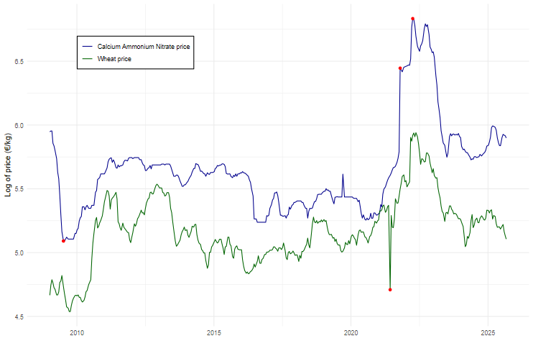

We replaced the identified wheat outlier following the Chen & Liu (1993) procedure. Detected outliers for the CAN time series occur after price shocks and are thus not removed.

Table A2 Summary statistics for price data
Statistic | log_CAN | log_Wheat | dif_CAN | dif_Wheat
Mean | 3.06 | 1.82 | 0 | 0
SD | 1.44 | 0.51 | 0.23 | 0.12
Min | 1.62 | 0.94 | -0.92 | -1.04
Max | 9.29 | 3.8 | 3.03 | 1.08
Skew | 2.52 | 1.25 | 6.75 | 1.15
Kurtosis | 9.3 | 5.51 | 89.6 | 44.23
ADF test | -2.47 | -2.73 | -8.47* | -9.05*
KPSS test | 1.45* | 1.42* | 0.07 | 0.08
PP test | -11.19 | -12.8 | -295.74* | -474.91*
Note: statistics rounded to the second decimal of Calcium Ammonium Nitrate (CAN) and wheat prices; * indicates the rejection of the null hypothesis at the 5% level for the Augmented Dickey-Fuller (ADF) test, the Kwiatkowski-Phillips-Schmidt-Shin (KPSS), and the Phillips-Perron (PP) test.

VAR model selection

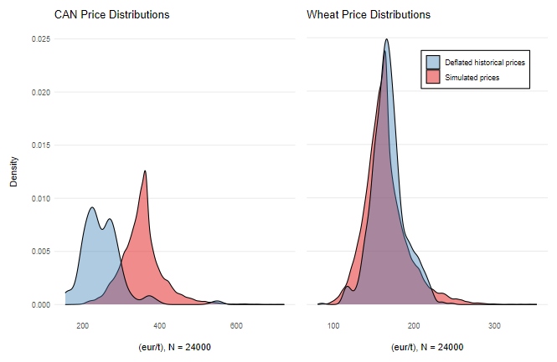
Figure A1. Density distributions of simulated and deflated CAN and wheat prices

Table A3. Summary statistics of simulated CAN prices, costs, and profits
 |  | strike | mean | median | sd | min | Max
CAN price paid | No contract | - | 0.356 | 0.355 | 0.028 | 0.279 | 0.523
 | Forward contract | - | 0.359 | 0.359 | 0 | 0.359 | 0.359
 | Adjusted contract | 0.355 | 0.345 | 0.355 | 0.015 | 0.279 | 0.355
 |  | 0.361 | 0.348 | 0.355 | 0.017 | 0.279 | 0.361
 |  | 0.368 | 0.35 | 0.355 | 0.019 | 0.279 | 0.368
 |  | 0.376 | 0.352 | 0.355 | 0.021 | 0.279 | 0.376
 |  | 0.388 | 0.354 | 0.355 | 0.023 | 0.279 | 0.388
Costs | No contract | - | 263.65 | 262.82 | 20.47 | 206.54 | 387.11
 | Forward contract | - | 266.04 | 266.04 | 0 | 266.04 | 266.04
 | Adjusted contract | 0.355 | 263.75 | 270.97 | 11.20 | 214.68 | 271.11
 |  | 0.361 | 263.49 | 268.75 | 12.60 | 212.46 | 273.33
 |  | 0.368 | 263.12 | 266.52 | 14.18 | 210.24 | 276.29
 |  | 0.376 | 263.86 | 265.78 | 15.69 | 209.50 | 281.48
 |  | 0.388 | 263.66 | 264.30 | 17.32 | 208.02 | 288.89
Profits broad framing | No contract | - | 1162.92 | 1122.59 | 312.96 | 279.36 | 2316.85
Profits broad framing | Forward contract | - | 1160.53 | 1120.58 | 320.86 | 262.26 | 2395.28
Profits broad framing | Adjusted contract | 0.355 | 1162.82 | 1123.57 | 317.80 | 271.21 | 2390.21
Profits broad framing |  | 0.361 | 1163.07 | 1121.78 | 317.08 | 273.44 | 2387.99
Profits broad framing |  | 0.368 | 1163.45 | 1121.99 | 316.33 | 275.66 | 2385.02
Profits broad framing |  | 0.376 | 1162.71 | 1120.81 | 315.62 | 276.4 | 2379.84
Profits broad framing |  | 0.388 | 1162.90 | 1121.86 | 314.76 | 277.88 | 2372.43
Profits narrow framing | No contract | - | - | - | - | - | -
Profits narrow framing | Forward contract | - | 2.39 | 3.22 | 20.47 | -121.07 | 59.5
Profits narrow framing | Adjusted contract | 0.355 | -0.1 | -8.15 | 13.23 | -8.15 | 115.99
Profits narrow framing |  | 0.361 | 0.15 | -5.93 | 11.85 | -5.93 | 113.77
Profits narrow framing |  | 0.368 | 0.53 | -3.7 | 10.31 | -3.7 | 110.81
Profits narrow framing |  | 0.376 | -0.21 | -2.96 | 8.71 | -2.96 | 105.62
Profits narrow framing |  | 0.388 | -0.02 | -1.48 | 6.71 | -1.48 | 98.22

Conte & Hey (2013) and Hey & Pace (2014), assessed the most relevant decision models under ambiguity broadly dividing them into those that use second-order probabilities and those that do not. Among the non-SOMs, Hey & Pace (2014) conclude that the Vector EU model (Siniscalchi, 2009) and the Alpha EU model (Ghirardato et al., 2004) perform better than the Subjective EU model (Savage, 1954) in explaining behaviour, but they perform similarly when it comes to prediction.
Other contract specifications may also include quality and time of delivery, and input suppliers can also offer additional benefits such as financing and fertiliser recommendations.
We do not specify other contract parameters like quantity, delivery, and settlement date, as they can be flexibly arranged for both cash and forward purchases.
Finger & Hediger (2008) analyzed different functional form for Swiss corn production and suggest that a square root specification of the production function leads to the smallest cost of misspecification.
Observed yields are yields simulated with the crop model, expected yields are derived from the production function.
With the assumption that 𝑔(⋅) is differentiable, and its error is serially independent with a continuous distribution function.
Data for German administrative areas was obtained from the Federal Agency for Cartography and Geodesy (BKG, 2025)
For more information about the EPIC-IIASA model specifications and calibration see Balkovič et al. (2013).
This sampling frequency generates calendar-related time gaps of 21 days (or 3 weeks). For analysis purposes, we assume this interval is consistent across years and does not affect the interpretation of temporal trends.
To check for stationarity we run three different tests: the Augmented Dickey-Fuller (ADF) test, the Kwiatkowski-Phillips-Schmidt-Shin (KPSS), and the Phillips-Perron (PP) test.
Exogenous variables investigated are squared endogenous variables, indexed time trends, and seasonal dummies. Information criteria improve with the addition of squared terms but we proceed with the linear model, as the non-linear specification does not produce a stable price simulation.
Based on phase 6 of the Coupled Model Intercomparison Project (cmip6). Outputs from the Institut Pierre-Simone Laplace (ipsl) and Max Planck Institute for Meteorology (mpi) climate models are considered to simulate yields under different Shared Socioeconomic Pathways (ssp); ssp126 is a low-emission scenario; ssp585 is a very high emission scenario (O’Neill et al., 2014).

